This project is a clone to the [The Piggyvest Create Account Form](<https://dashboard.piggyvest.com/register>). PiggyVest helps over 3 million customers achieve their financial goals by helping them save and invest with ease.

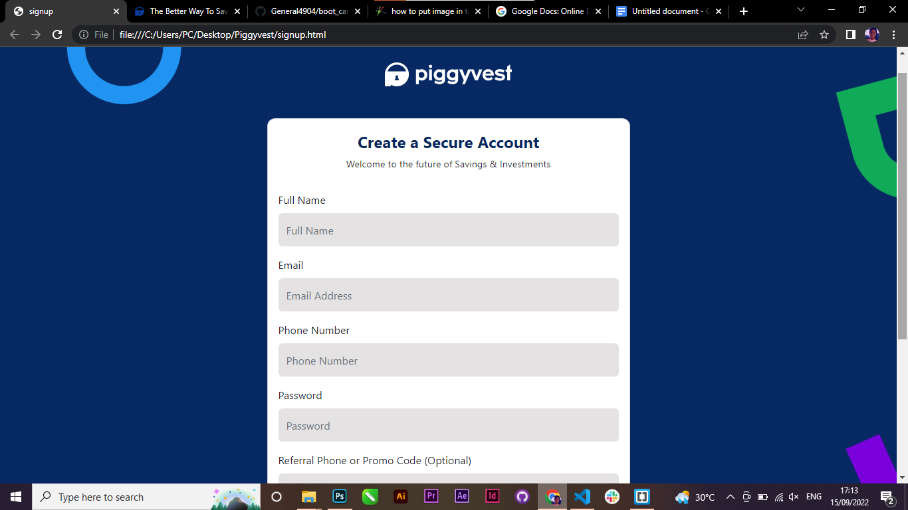

**My Process**

**#Built with**

- Semantic HTML5 markup

- CSS custom properties

- Bootstrap 5

**#What I learned**

I learnt how to use **Css Border Radius** the write way while styling the card for the form. And I got to understand that it works the same way with Css Padding.